Project Plan

Find It : *Painless Shopping*

Mohamed Amadou

Samuel Jones

October 2nd, 2016

Contents

1.0 Introduction

1.1 Synopsis

1.2 Mission Statement

2.0 Requirements

2.1 Client-Specific Requirements

3.0 Deliverable List

3.1 Core Functions

3.2 Extended Functions

4.0 Tasks

4.1 Workflow

4.2 Task list & Schedule

5.0 Risk Analysis

5.1 Quantitative & Qualitative Analysis

5.2 Preventative & Restorative Measures

6.0 Team Policies

1.0 Introduction

1.1 Synopsis

The object of Find It is to provide user with the feeling of browsing a store with having to be in the store through pictures, prices, store stock, etc.

1.2 Mission Statement

To facilitate shopping by providing consumers with a list of local items based on a search query. (ex. Someone searches for khakis, they would get a list of khakis in Ottawa sorted by price, distance, etc.)

2.0 Requirements

2.1 Client-Specific Requirements

Sophie, our client, has specifically disclosed that the final product must satisfy the following criteria;

* Android compatible app (free)
* Must work for entire Ottawa area
* Must have price comparison function for 3 specific items \*at the same time\*
* Must analyze ;stock, location, price, and brand

3.0 Deliverable List

3.1 Core Functions

1. Search local stores

1.1. Must work for entire Ottawa area

2.Item prices

2.1 Retrieve item prices from store websites

2.2 Format and display these prices on the screen

2.3 Must have price comparison function for 3 specific items \*at the same time\*

3. List sort (to organize list based on price, distance, etc.) to fit a customer’s needs

3.1 Sort in alphabetical order

3.2 Sort in reverse alphabetical order

3.3 Sort by price (High to Low)

3.4 Sort by price (Low to High)

4.Store categories (ex. Browse clothing, technology, appliances)

//stuff

5.Which stores are closest

//stuff

6.Shopping list (save items for later viewing)

3.2 Extended Functions

* Suggested items (based on previous searches)
* Set a budget(Gives different options to stay under budget) also includes setting a shopping list budget
* Tells you which stores have student discounts
* Input Different Coupons / Discounts you have and the prices will be applied

4.0 Tasks

4.1 Workflow

The following PERT chart defines the path to be taken when creating the product, defining the process and the objectives to be completed.

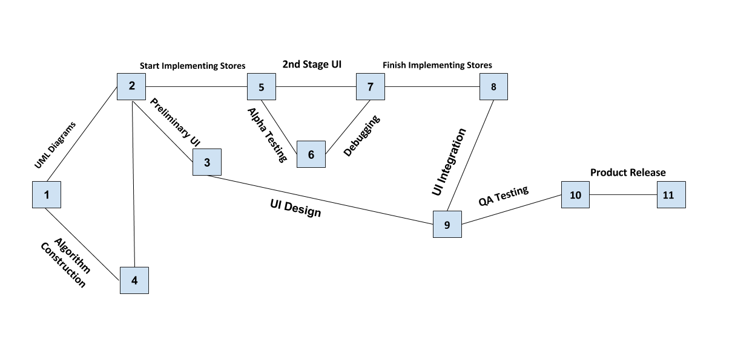

4.2 Task List & Schedule

The following GANTT chart defines the objectives that must be completed for the project to run on schedule and be done to a good level by the due date.

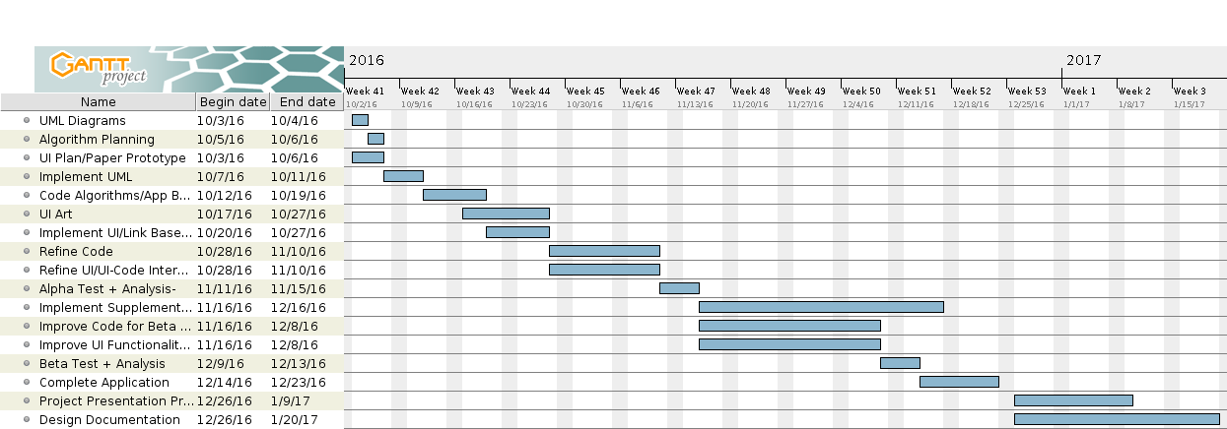

5.0 Risk Analysis

5.1 Quantitative & Qualitative Analysis

For the purpose of simplicity, we’ve separated the potential risks into appropriate categories. We’ve also kept the risk assessment in the format

Risk Value = Probability of Event x Cost of Event

(Since the app is free, the cost of the event will be measured in time rather than money)

The Official Span of the Project is 67 days ( October 3rd - December 9th)

At a minimum pace of 7.5 hrs per week (~375 min of school + 75 mins of weekend), that sets the duration of the project to about 90 hours $±$ x% (x is determined by the risk analysis)

Human - Illness, injury, or other loss of a key individual

I. Member gets sick (to the point that they can’t contribute) - 0.05 x 45h | Risk Value : (2.25)

II.Member breaks fingers or gets concussion - 0.15 \* 25h | Risk Value (3.75)

III.Member must leave on a trip - 0.40 \* (1 - 7.5h) | Risk Value (0.4 - 3)

Operational - Loss of access to essential assets

IV.Google Maps goes down - 0.001 \* 50h | Risk Value (0.05)

V.We Lose Access to GitHub - 0.01 \* 20h | Risk Value (0.2)

VI.Mohamed Breaks his Computer and thus, loses Design Assets - 0.1 \* 30h | Risk Value (3.0)

Reputational - Loss of client confidence

VII.Sophie (Our client) changes her mind mid-development - 0.4 \* 10h | Risk Value (4.0)

Procedural - Accountability Failure/Internal Strife

VIII.Either Sam or I falls behind due to unavoidable reasons - 0.5 \* 5h | Risk Value (2.5)

IX.Petty Argument within the group ruins workflow - 0.01 \* 10h | Risk Value (0.1)

Project - Product Quality issues

X. QA Testing reveals fatal flaw at end-stage development - 0.05 \* 80h | Risk Value (4.0)

From this Risk Analysis we can conclude that the average risk value (100x/90) is equal to

2.25 + 3.75 + 1.7 + 0.05 + 0.2 + 3.0 + 4.0 + 2.5 + 0.1 + 4.0 = 17.55

X = 19.5%

Therefore the duration of the project, accounting for potential risk is 90 hours $±$ 19.5% (17.5h)

5.2 Preventative & Restorative Measures

Preventative Measures

1. Stay conscious of weather & maintain good physical health.
2. Be cautious when engaging in activities that could potentially endanger your well-being
3. Try to push back any plans to a weekend or put in extra hours to finish work quota before departure
4. This point has the highest risk factor because we have no control over Google Maps. A preventative measure though could be downloading the ottawa area for offline use
5. Keep working files on multiple FTP clients / cloud services to prevent catastrophic data loss (i.e. FileZilla, Google Drive, home desktop)
6. Backup design assets on another computer so that if for some odd reason we end up losing my computer, we’re not totally blindsided.
7. Keep client constantly updated and show them what is and what isn’t up for debate at certain stages in the development life cycle
8. N/A
9. Realize that we have a duty to create a quality product for our client and that our personal turmoil will do nothing productive
10. Spend a lot of time developing algorithms and create a very solid plan before implementation begins

Restorative Measures

1. Take Medicine and maybe get a family member to help write down pseudocode so that you can still contribute
2. Focus on recovery so that you’re up and ready to go as soon as possible
3. Give team member full schedule so that we can workout a way to makeup for the lost time in advance
4. N/A
5. Use one of the other 2 backup FTP clients / cloud storage services
6. Use Backup Computer
7. Improvise, if this ends up happening there’s not much we can do about it
8. Work hard to catch up
9. Introduce a 3rd party to the situation to mediate
10. We’ll have to put in A LOT of overtime to get back on track if this happens

6.0 Team Policies

To work as a team we have planned to use many resources that facilitate communal code writing and editing and resource sharing.

To program the app we have planned to Android studio with Github integration so that we may share things easily but also learn about Git and it’s use in a professional environment.

To share our resources, such as plans and other documents, we plan to use Google Drive because of it’s cheap cloud storage option, along with it’s ability to edit with multiple at once.